
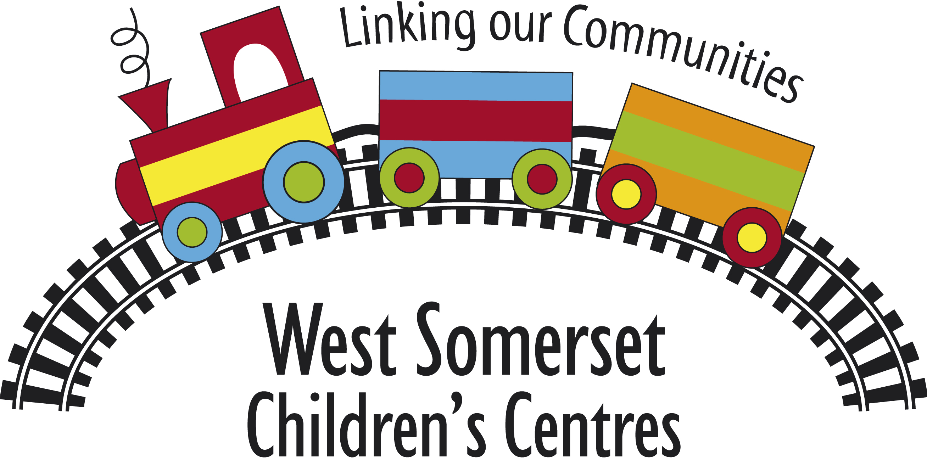

Outcome Focused
Case Study

Services Received:

Partnership Services: (eg HomeStart)
The family have received weekly home visits from a Home-Start trained volunteer under the outreach contract. Each visit lasting between 2-3 hours. Also regular phone contact between family and volunteer to offer additional support.

Profile of individuals/group:  (eg age/number in group/age of child/ethnicity/gender etc) | e-start:
The family group is made up of Mum (32), her male partner (34) and one little boy aged 8 months. They are a white British family and live in a rural village in Exmoor. The family have completed an e-start and are registered at Alcombe Children’s Centre.

Outcomes – Success Indictors:
- 2 - Strengthen family relationships
- 4 - Promoting healthy lifestyles
- 5 – Increase opportunities for parents to improve their personal skills, education and employability

Children’s Centre Involvement
The family have been included in the Children’s centre outreach project. Their inclusion has now come to an end.

Children’s Centre Contact/RFI
N/A

Summary:
Why outcomes were needed:
The family were new to the area, having moved here to find work. Mum had become pregnant unexpectedly and did not feel “ready” to be a mum. She was isolated both rurally and socially once the baby came along.
How outcomes were achieved:
The outcomes were achieved by placing a trained volunteer with the family who quickly became a trusted friend. The volunteer helped access local services by providing transport as appropriate, as well as being a great source of encouragement and emotional support.
What helped outcomes to be achieved:
Regular supervision of the volunteer and reviews with the family, carried out by one of the professional staff ensured safe, supportive and effective working practices.
Efficient signposting and accompanying to other relevant services.
The generosity and compassion of an experienced and trained volunteer.
Barriers to achieving outcomes:
Rural transport has been a problem for this family. They have no available transport so links to services/work etc. are limited. The volunteer has regularly transported the family so that they can attend appointments, job interviews and local services.

Impact
(Were outcomes achieved?)
The outcomes have been achieved but we will continue to work with the family as other needs have been identified during the support period. It can take a long time to get to know a family and for them to feel comfortable enough to share their deepest concerns.

Quotes/summary from parent:
Mum says that it has been great having someone to share her challenges with. She has no friends or family locally and it has made a difference having a confidential “friend”. Mum has told other people about Home-Start who have then gone on to refer themselves to the service.

Follow On:
(Referred to Homestart, etc)
Home-Start will continue supporting the family for the time being as new outcomes have been identified.

3 Month Review
At the 3 month review mum felt that she was just beginning to form a relationship with her volunteer. Since moving to the area she has been unable to integrate into the community due to her lack of confidence and issues of being let down by other people, but together her and the volunteer had accessed a couple of groups and although mum was still feeling very shy she was enjoying the interaction with other new parents and felt that her baby was benefitting from the socialisation.
With the encouragement of her volunteer she had continued to breastfeed and was now confident that this had been the right decision and best for baby.
Her relationship with her partner was starting to improve as she was feeling less isolated and less like she had drawn the short straw in the relationship.

6 Month Review
At the 6 month review mum was visibly more confident and baby was thriving. With the support from her volunteer mum had sought advice and information about her statutory rights regarding maternity leave and had returned to work on a part time basis. Baby is now regularly attending nursery whilst mum is working.
The return to work has been stressful for mum and she feels that her employers have not been fair in their approach. With the volunteers support she is now accessing ACAS for employment advice.
The relationship between the parents is now stronger and they are working as a team rather than against each other to “score points”.
Mum is now starting to try baby lead weaning and the volunteer is being very encouraging with this.

9 Month Review
N/A

Name: Janet Costello | Date: 10.12.13

