Information
PROVIDING SUPPORT FOR COUNTY COUNCILLORS
Sheet Number:
2017-21/15
for County Councillors
From: | Trudi Grant
Date: | 15th August 2017
To: | All County and District Councillors
Somerset: Our County - Joint Strategic Needs Assessment 2017

The JSNA is a statutory responsibility for all Health and Wellbeing Boards. It brings together information about the place, the people and their social and health status to give us a well-rounded picture of what it is like to live in Somerset. The summary of the JSNA, which this year has a focus on ‘ageing well’, is published at www.somersetintelligence.org.uk/jsna along with a qualitative report exploring some Somerset resident’s views on what helps us age well and what doesn’t.

The points below summarise the findings from both the data and qualitative information that has informed this JSNA. These points have been written to advise how services could be developed and delivered in the future.

Remaining healthy
- Prevention first and foremost - Nearly half the burden of disease for older people can be attributed to conditions that can be prevented or delayed by changes in lifestyle. The ‘usual suspects’ - not smoking, drinking responsibly, maintaining good social contacts, eating well and exercising – contribute strongly to ageing well.
- Dementia is the condition most associated with getting older. This risk, too, can be reduced by a healthier lifestyle earlier in life.
- There is no ‘safe age’ before unhealthy activities begin to have an effect, nor an age after which improvements do not help.
- Many older aged people are keen to engage with younger people on matters relating to health and wellbeing, they are keen for young people to learn from their own (older people’s) experience. Many services and communities would benefit from utilising and supporting this natural resource.
- The importance of maintaining social and intergenerational contact is clear and needs a far greater emphasis in the future.
- Inequalities in health are very evident, with a small number of poorer older people having a disproportionate burden of disease and so increased cost to health and care. A far greater focus on reducing inequalities will improve lives and save public money.

Remaining independent
- Staying independent, preferably in one’s own home, is important to older people, there is a great deal of emphasis on more self-help and short-term assistance to regain independence.
- Formal health and care exist within a wider context of the immediate and extended family, and the voluntary and community sector. The contribution and needs of family carers in particular, needs greater recognition.
- Good transport helps independence and social contact in town and the countryside, affordable and sustainable transport solutions are important to keeping older people healthy and well.
- Design and local planning policy has a significant impact on health and independence, particularly for older people seeking appropriate housing solutions without having to move out of their community and away from their social support. Housing policy should take health and wellbeing impact into account.
Remaining active and included in community life
- Social contact is an essential part of sustaining health and wellbeing.
- Volunteering is of benefit to the community and to the volunteer.
- Rewarding and valued work is good for health. Employers should recognise the contribution to be made by older workers, including people past current state pension age.
- Supporting stronger communities through village agents, town and parish councils and voluntary groups such as Men’s Sheds provides a cost effective way to health and wellbeing across all ages.
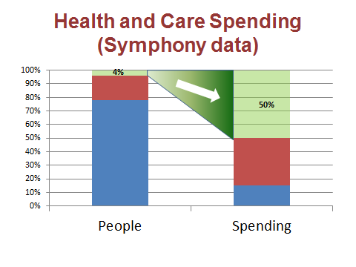
- Maintaining social contact into older age can create a support network that helps people stay independent in their own homes.

The graph above uses information from ‘Symphony’, part of the Yeovil District Hospital Vanguard project. It brings together information about the costs of providing health and social care for individuals in Somerset. The graph shows how just 4% of the population – mostly elderly and all with multiple long term conditions such as diabetes and high blood pressure – contribute 50% of the spending in health and care. Keeping people healthy, connected and independent – and so out of this most needy 4% for as long as possible - not only helps their wellbeing, but makes financial sense for public services.

For more information please contact: | Name: Pip Tucker – Public Health Specialist Jo McDonagh – JSNA Project Manager  Email: pztucker@somerset.gov.uk; jmcdonagh@somerset.gov.uk  Tel No.: 01823 359449/01823 357275
Members Portal - http://somerset.learningpool.com/

