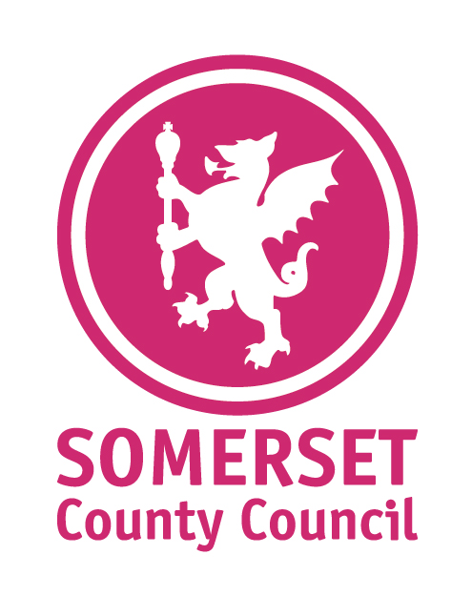
Information
Sheet Number:
2022-27/32
Providing support for County Councillors
for County Councillors

From: | Amy Hardwick, Health Promotion Manager – Mental Health and Wellbeing

Relevant SLT Director and sign-off date: | Trudi Grant - 28/11/2022

Date: | 02/12/2022

To: | All County Councillors

The Orange Button Community Suicide Prevention Scheme – How to take part.
The Orange Button is a new community suicide prevention scheme that launched in Somerset in October. The scheme was created in recognition that the majority of those who sadly take their lives are not known to Mental Health Services.
We need to raise awareness of suicide in our communities, we need to tackle the stigma surrounding suicide and we need to spread the message that talking to someone in distress won’t make the situation worse.
The Orange Button badge is worn by people in Somerset who have undergone quality assured mental health or suicide prevention training: whilst they are not able to counsel people, they can help you to find relevant services locally.
The Orange Button signifies that the person displaying it is:
- OK to say/hear the word suicide
- Can listen without judgement
- Can support people with signposting
Scheme aims
- Create a community of people trained in suicide awareness that have gained skills to help people from quality assured training.
- Create a network of organisations that have Orange Button wearers in place that can be easily identified who are able to listen and signpost.
- To ensure all communities are aware of the Orange Button, what it signifies and how people can be involved, by promoting from within the community. Elected Members are pillars of their community - therefore we are encouraging all Members to complete the training to become Orange Button wearers to support uptake and awareness of the scheme across Somerset.
The Orange Button is important because…
- It seeks to raise awareness and reduce the stigma surrounding suicide
- Suicide is everybody’s business
- Training will help give people confidence to trust their instincts and start a conversation, which could save a life.
Step 1 – How it Works
If you would like to become an Orange Button holder, you will need to have completed; at least three hours of quality assured mental health or suicide prevention training. This is to ensure you are equipped with the skills to listen and signpost people.
The Orange Button Scheme is linked to (but not limited to) any one of the following funded training courses through Somerset Public Health:
- Every Life Matters – Suicide Alertness (Half Day course) – professionals and public
- ASIST (Applied Suicide Intervention Skills Training) – professionals
- Mental Health First Aid (MHFA) (2 day – Adult) – professionals
Step 2 – How can I get an Orange Button?
Once you have completed the training you can sign up to be an Orange Button holder on the Mind in Somerset website.
The scheme is entirely voluntary and there may be days where you decide you don’t feel able to wear your badge. At all times keep yourself well and be self-aware, wearing the badge is your choice, only wear it when you feel well enough to support others.
Orange Button holders receive quarterly newsletters, which provide updates on services/support available, further training opportunities, events and helpful resources.

For more information please contact: | Name: Amy Hardwick  Email: amy.hardwick@somerset.gov.uk  Telephone: 07976699718

