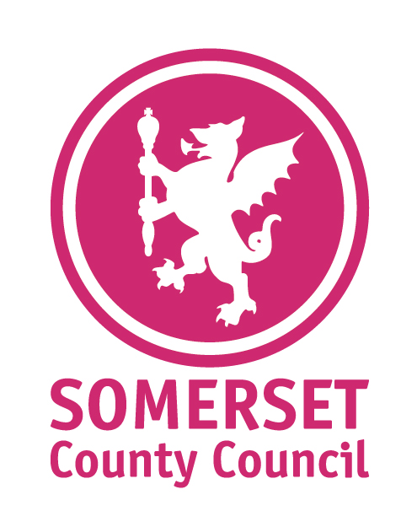
Information
Sheet Number:
2022-27/30
Providing support for County Councillors
for County Councillors

From: | Andrew Melhuish – Service Manager Democratic Services

Relevant SLT Director and sign-off date: | Jason Vaughan (S151 Officer & Director for Finance & Governance)  Scott Wooldridge (Monitoring Officer & Strategic Manager – Governance & Democratic Services)

Date: | 24 November 2022

To: | All County Councillors

Member Allowances – new rates!

Please note that the Basic Allowance Rate for 2022/2023 has been increased by 5.6%.

This new rate will see the Basic Allowance increase from £11,742 to £12,400. The change to the Basic Allowance will also be reflected in any Special Responsibility Allowances currently paid.

The new rate will be backdated from 1 April 2022, and your November payslip will reflect the new amounts.

Background:
- Current BA for SCC = £11,742
- Joint IRP recommended BA to increase in line with a % pay award to staff (approved at Full Council in February 2022)
- Staff pay award now agreed as a flat rate increase of £1,925 for a full-time member of staff
- Recent decision by S151 Officer proposes an increase of 5.6% to reflect an average across the staff pay increase
- BA for SCC with 5.6% increase £12,400

For more information please contact: | Name: Andrew Melhuish  Email: andrew.melhuish@somerset.gov.uk  Telephone: 01823 355927

