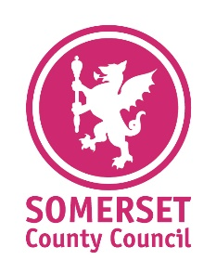
Information
Sheet Number:
2017-21/178
Providing support for County Councillors
for County Councillors

From: | Stephen Marsh

Relevant SLT Director and sign-off date: | Carlton Brand
Date: | 12 March 2021

To: | All Joint Councils’ Members
How to take part in the Government’s consultation on local government reform in Somerset

The Government has now launched an eight-week consultation on local government reform in
Somerset. The Government is seeking the views of key organisations including public sector
partners, neighbouring authorities, the business and VCSE sectors and elected members.
The Government is consulting on the two proposals that have been submitted – One Somerset,
Somerset County Council’s (SCC) preferred option that would create one single unitary authority,
and Stronger Somerset, proposed by the four district councils, that would create two unitary
councils in the east and west of the county, an alternative delivery model (ADM) for the delivery of
children’s services, a shared services company and a combined authority.
The consultation is being hosted online and asks a number of questions about the merits of each
proposal. You, therefore, have the opportunity to comment on both proposals if you wish.

You can find out more information about each proposal by visiting their dedicated websites: -
One Somerset website: www.onesomerset.org.uk
Stronger Somerset website: www.strongersomerset.co.uk

Your views count, so please take a moment to participate. Please do encourage any contacts you think would be interested in participating to also participate.
The consultation closes on Monday 19 April, so don’t delay in responding.

- Logon to the Government’s consultation website:
Somerset Unitarisation - Ministry of Housing, Communities and Local Government Citizen Space - Citizen Space
- Enter your details and answer the questions on Stronger Somerset and/or
One Somerset
- Click submit

You can also write or email your comments to the Government direct, making clear that you are commenting on the Somerset consultation.

Email: unitaryconsultation@communities.gov.uk

Postal address:
Governance Reform and Democracy
Ministry of Housing, Communities and Local Government
2 Marsham Street
London
SW1P 4DF

Please contact the One Somerset
team for any further assistance
onesomerset@somerset.gov.uk

