Command and Control
Strategic (Gold)  STRATEGIC LEAD  Chief Executive or Nominated Deputy  Supported by Civil Contingencies Manager  What needs to be done? |  | Brief Lead  Elected Members
Tactical (Silver)
TACTICAL LEAD
Strategic Director of Affected District
plus Tactical Delivery Group Leads
Supported by Civil Contingencies Team

How are we going to do it?
Operational (Bronze)
OPERATIONAL MANAGERS
Service Delivery Teams

Doing it

Definition of an Emergency
“An event or situation which threatens serious damage to human welfare in a place in the UK, the environment of a place in the UK, or war or terrorism which threatens serious damage to the security of the UK.”

You are informed of an emergency in your area – What do I need to do?

Make a note of the details of the emergency
- Who is informing you?
- Note time of message.
- Date and time emergency occurred.
- Where is the emergency?
- What is the nature of the emergency?
- Note of any actions taken or decisions made.
- Keep your log safe in case needed later.
- Inform your Communications Officer.

Your Communications colleagues, who will be involved in the incident, will do their best to keep you updated through the usual channels. You should also monitor your local authority social media accounts.

Please See “Do’s and Don’ts” overleaf

For further information contact:-
Somerset Local Authorities’ Civil Contingencies Unit on infoccu@ somerset.gov.uk or your District Civil Contingencies Manager for further information (Section 4 of Handbook).

Look at www.somersetprepared.org.uk for community plan templates and information.

Quick Guide
Somerset Elected Members’ Emergency Handbook

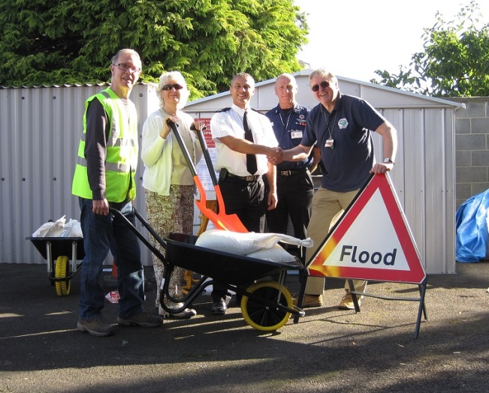
Cheddar Community Support Day

Cheddar Community Support Day
An emergency can happen at any time – so please give yourself time to read the full Somerset Elected Members’ Emergency Handbook and be prepared.

November 2018
Role Before Emergency
To aid preparation for your role before an emergency occurs, be aware of or check the following:-
- Civil Contingencies Act 2004
- Somerset Local Authorities’ Civil Contingencies Partnership
- Emergency management
- Emergency plans in place
- Plans tested by exercises
- Local community hazards and risks
- Active community engagement
- Encourage community resilience
- Resilience awareness and media training

Role During Emergency
In the early stages there is little or no action you can take as Elected Members. The Emergency Services and Officers must be allowed to manage the situation. At this point:-
- Support Local Authority Officers response
- Provide community leadership in your area
- Attend Community Recovery Committee to aid relief efforts
- Lift morale of affected community and staff
- Identify community needs
- Agree a visit to the Emergency Centre
- Keep a log of actions for debriefs/inquiries
- Receive briefings from Chief Executive or Communications Manager

Role After Emergency
You can make a significant difference during the recovery stage of an emergency. You have a duty as a community representative to report community concerns to the Recovery Working Group and feedback information and advice. You can:-

- Show strength, inspiration and leadership to help the return to normality
- Have valuable knowledge of people and resources available in the community
- Hold surgeries and signpost to services
- Support work of recovery teams
- Consult on regeneration, rebuilds and modernisation
Please Do
- If requested to go to a rendezvous point, take your time, have something to eat and drink first, you do not know how long you will be out.
- Wear appropriate clothing, eg sensible footwear, warm or wet weather clothing.
- Report your arrival and departure to the designated officer in charge at the rendezvous point.
- Speak to Communications Manager for update on emergency and media strategy
- Start a log with details of calls and any actions taken.
- Stay safe
- Promote agreed media messages
- Liaise with other elected representatives
- Assist with debrief sessions in community
- Assist with VIP visits
- Work to administer Disaster Appeal funds
- Participate in community self-help groups
- Attend memorial/remembrance services
- Ensure lessons learnt from response are included in emergency plans

Leaders of Councils/Cabinet Members/
Portfolio Holders will have specific roles, as outlined in the Handbook, including strategic leadership, policies, decision making, expenditure, scrutiny and monitoring of emergency planning and emergency response.

Please Do Not
- Rush to the scene if not requested to, there will be a very good reason for you not attending, eg personal safety.
- Speak to the press or use social media without being fully briefed by the Chief Executive or nominated Officer – the Communications Manager will be part of a multi-agency Communications Group in order that a co-ordinated message is given by all agencies involved.

PLEASE DO
- If requested to go to a rendezvous point, DO NOT RUSH, have something to eat and drink first – you do not know how long you will be out.
- Wear appropriate clothing, eg flat shoes, warm clothing, wet weather clothing.

- Report your arrival and departure to the designated officer at the rendezvous point.

