Providing support for County Councillors
Information
Sheet Number:
2017-21/219
for County Councillors

From: | Jo McDonagh- Public Health

Relevant SLT Director and sign-off date: | Trudi Grant  22/02/2022

Date: | 22/02/2022

To: | All County Councillors

SOMERSET: Our County 2020/21 COVID-19 in Somerset Communities

Please see information below:

For more information please contact: | Name: Jo McDonagh  Email: JMcDonagh@somerset.gov.uk  Telephone: 01823 357275

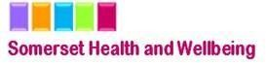

SOMERSET: Our County 2020/21 COVID-19 in Somerset Communities

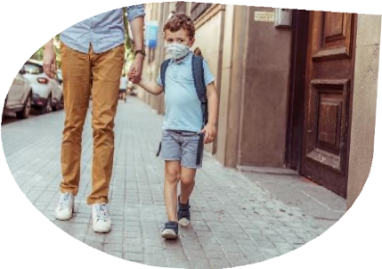
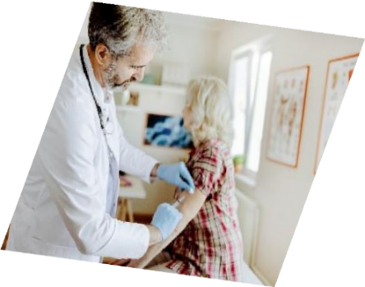
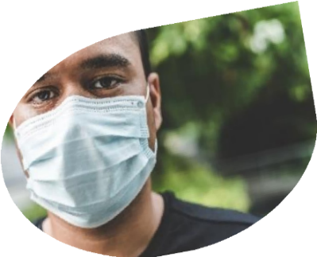
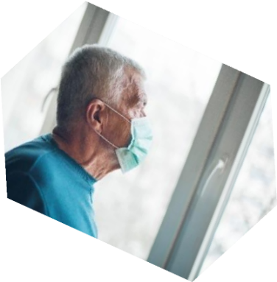
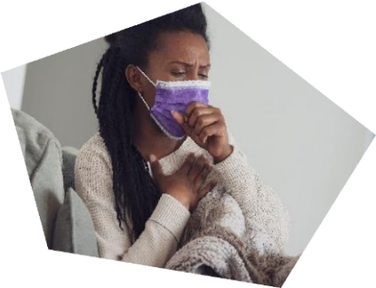
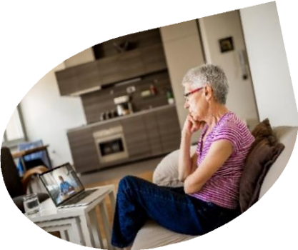

Annual Summary of the Joint Strategic
Needs Assessment for Somerset
Autumn 2021

Summary
Focus on the areas of greatest pre-existing need
This is the first annual summary of Somerset’s Joint Strategic Needs Assessment (JSNA) since the start of the COVID-19 pandemic. It is an initial investigation to understand its impact on the pattern of health needs in Somerset. It would be impossible to cover every aspect at once, so this focuses on the communities with the greatest concentration of need before the pandemic, using the 10% most deprived areas in the county, according to the Index of Multiple Deprivation (IMD). Comparison with the rest of Somerset allows some insight as to what is happening elsewhere. This describes the situation down to the autumn of 2021.
It was not a simple exacerbation of existing inequality
This focus allows us to test whether the often-stated national effect of the pandemic worsening existing inequalities, applies here; we found that the impacts were far more nuanced than that. COVID-19 rates have been somewhat higher in deprived areas, and relatively low take-up of vaccination means that this will probably persist. However, the contrast between more and less deprived areas was less than we might have thought. The most worrying finding on physical health is a relative increase in emergency cancer admissions for these communities, which implies delays in seeking treatment. For domestic abuse, drug and alcohol abuse and anti-social behaviour we saw little immediate impact, and for unemployment – a key ‘wider determinant of health’ – the greatest proportionate growth was outside these areas.
Family resilience and benefit schemes helped these communities cope at the start Some people - already in need - had, crudely, ‘less far to fall’; they also had coping mechanisms and social – especially family – support in place and showed considerable resilience, especially at the start. Furlough and the £20 Universal Credit uplift have undoubtedly played a part; these were unprecedented responses to an unprecedented event. Finally, there is a risk that the lack of contact with needy families, especially when schools were closed, meant that need was not identified as it might normally have been.
Services found new ways to reach their clients
We heard about digital access, with poverty and confidence as barriers. Improving it helps service users and service providers alike. We heard from Citizens’ Advice Bureau and Somerset Drug and Alcohol Service how effective new ways of working can be.
The impact has been slow but growing powerfully
The impact on families and mental ill health has been a ‘slow burn’, with lockdown pressures increasing the risks of domestic abuse and anti-social behaviour, and for some, as we heard, “It is the structure of life that went, really.” The end of furlough and the £20 uplift, and rising prices, may raise these pressures even as lockdown eases. The reports of hunger amongst young people were perhaps the starkest statement of real need in these communities.
Previously less-deprived communities may now have new needs.
Finally, the evidence of increasing need in previously less-deprived communities should be examined further. It may be that without established coping mechanisms, and exacerbated by access issues, there are cohorts who are newly in need whose concerns need addressing.

Contents
Summary 2
Introduction 4
Where are the communities? 4
Pre-pandemic characteristics 5
Population 5
Components of deprivation and employment 6
Housing 6
Impact of COVID on vulnerable communities 8
Incidence of COVID 8
Long COVID 8
Secondary health effects 9
Access to healthcare 9
Hospital admissions 9
Mental health 14
Depression and anxiety 14
Welfare and Wellbeing 15
Economic Impact on health and wellbeing 16
Unemployment and Benefit claimants 16
Education 17
Digital access 18
Voluntary sector and social support 19
Crime and anti-social behaviour 21
Drugs and Alcohol 23
Food and hunger 25
Observations (Sedgemoor Conversation) 25
Youth Unlimited 25
Vaccination 26
Conclusions 27
Implications for commissioning 27

Introduction
On the 11th March 2020, the World Health Organization declared the outbreak of COVID-19 to be a pandemic. This has been a health-induced shock to humanity. Somerset may have escaped the very worst of the direct impacts, but the disease, ‘social distancing’ and lockdown measures mean that the landscape of health and wellbeing has been transformed. The implications for decision-making in Somerset are so profound that no single study, especially when the crisis is far from over, can cover it all. Here, we will start the task of building a new Joint Strategic Needs Assessment by looking at its impact in the communities with the highest concentration of need before the pandemic.
The starting hypothesis is that these areas will have seen not only the greatest need before the pandemic, but the largest proportion of the population that has gone from ‘just about managing’ to ‘not managing’: that, of course, is what will be tested.

Where are the communities?
The communities will be defined according to the Index of Multiple Deprivation, selecting the 10% of areas scoring the highest on that measurei. More importantly, information about these communities can be used as a lens to understand conditions across the whole county by identifying similarities and differences. Nine settlements – Taunton, Yeovil, Bridgwater, Frome, Wellington, Highbridge, Glastonbury, Minehead, Chard – have at least one Lower Super Output Area (LSOA – a statistical definition of a geographical area that has approximately 1,500 people or 650 households) that falls into this category.

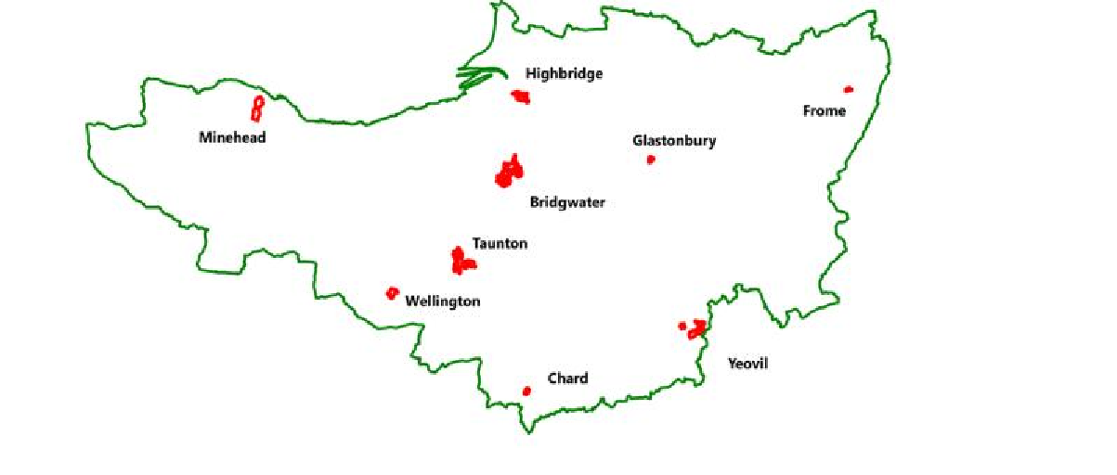
Figure 1: Location of the 10% LSOAs scoring highest on the Index of Multiple Deprivation

Pre-pandemic characteristics

Population
90 and over
85-89
80-84
75-79
70-74
65-69
60-64
55-59
50-54
45-49
40-44
35-39
30-34
25-29
20-24
15-19
10-14
5-9
0-4
4%
3%
2%
1% 0% 1%
2%
3%
4%
Males Females
Figure 2: Population Pyramid - Communities in solid bars, Somerset average as hollow bars

The communities in question have a broadly younger population than the county as a whole
- seemingly many young families with children, as shown in Figure 2: Population Pyramid - Communities in solid bars, Somerset average as hollow barsFigure 2. Ethnic breakdown in the communities in question is not very different from the county average, at least using the headline data from the 2011 census, with 98% in the communities being White, and of them 96.6% being ‘White British or Irish’. Although national evidence suggests a greater impact amongst ethnic minorities (Office of National Statistics (ONS) reference), it is unlikely that this is a significant factor in any differences between these communities and the rest of the county. Most of the population is either Christian or of no religion. Nationally, both are associated with relatively low levels of COVID-19.

Components of deprivation and employment
The seven domains of the IMD give an indication of the type of deprivation in communities. In this case, as shown in Figure 3, it is generally the level of skills in the adult population and school age exam results and attendance that contribute most to their difference. On some measures, notably related to access and affordability, some are less deprived than the average, and this picks up some differences between the larger and smaller settlements.ii
On average, harmful behaviours are more prevalent in deprived communities. Lack of exercise, excess weight and smoking all increase the risk from COVID. Air quality and housing standards are typically worse, and also contribute to respiratory illness.

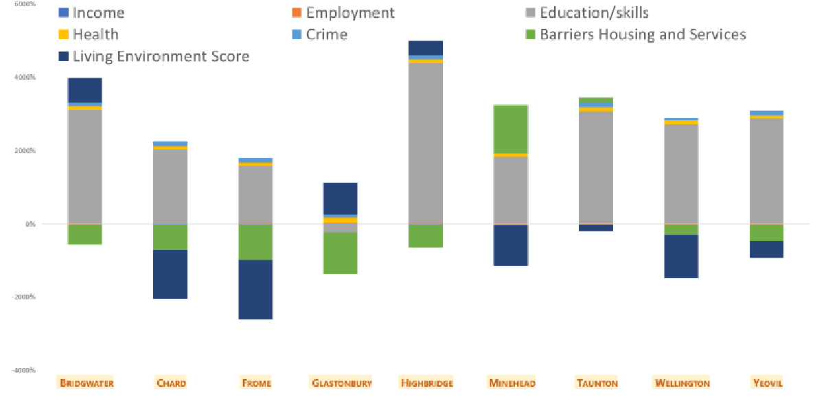
Figure 3: Deprivation domains in Somerset Communities

The communities in the towns being studied have a relatively high proportion of the population in the accommodation and retail, and manufacturing sectors (40% of the working population), and a higher proportion at the lower-skilled and lower-paid end of the scale (19% of the workforce in elementary occupations). These sectors and occupations were generally hard-hit by lockdown restrictions.

Housing
Housing patterns are likely to have changed considerably since the 2011 census, especially because of the effects of the Hinkley Point C work on Bridgwater and Taunton, so census data may appear very dated. The ONS has identified that, nationally, there is a high incidence of COVID associated with ‘houses in multiple occupation’ (HMOs), especially when occupied by large households – often of South Asian origin – or migrant workers, typically from Eastern Europe. In Somerset, it has been reported that many HMOs have been linked to COVID outbreaks, particularly among migrant workers from continental Europe working in

the food processing industry. Such HMOs are concentrated in the inner urban areas considered here. The figures for South Somerset are shown in Table 1 (directly comparable recent figures are not available for other districts).

Table 1: Houses in Multiple Occupation - South Somerset

Yeovil | HMOs
Central | 96
South | 34
West | 10
East | 36
North | 4
Avishayes | 9
Combe | 4
Holyrood | 7
Jocelyn | 3
Rest of South Somerset | 32

Impact of COVID on vulnerable communities
Unlike the 2013 floods or the 2008 economic crash, the COVID-19 crisis started out as a health problem. Like these major events, though, the pandemic has had repercussions well beyond the initial shock. A framework for this was discussed by the Chief Medical Officer, Chris Whitty, which separated out the direct health effect of catching COVID-19, the impact of an overwhelmed urgent care system (which was largely avoided and will not be discussed here) and the impact of delays to non-urgent treatment, as well as the continuing impact of the economic and social effects of the pandemic, and its responses, notably ‘lockdown’. This report will consider how these aspects have played out in the more deprived communities of Somerset and compare them to the county as a whole.

Incidence of COVID
As shown in Figure 4, the incidence across the first two waves of the pandemic, at 72/100,000, was higher in the most deprived decile than any other decile. However, the higher incidence, whilst real, is not marked, unlike many aspects of public health, where ill- health and vulnerability are often strongly concentrated in these communities.

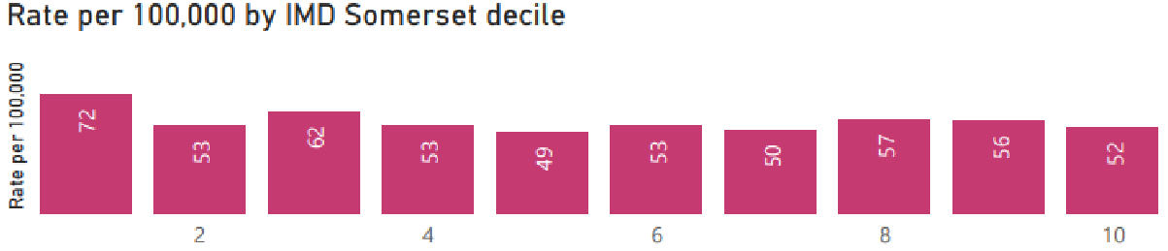
Figure 4: Overall case rate. A reflection of the number of individuals who have had COVID-19 and tested positive.

Long COVID
Nationally, self-reported long COVID was most likely among women aged 35-69, living in the most deprived areas, working in health or social care and having an existing health condition or disabilityiii.
These would suggest that the communities being studied would have higher incidence of long COVID than elsewhere, but this is not evident in referrals to Somerset’s long COVID service (by September 2021).

Secondary health effects

Access to healthcare
Figure 5 and Figure 6 show the pattern of hospital admissions before and during the pandemic, comparing the poorer communities with the county as a wholeiv. Unsurprisingly, before March 2021 the level of admissions was higher than during the pandemic – elective admissions were curtailed because of need to maintain hospital capacity, and emergency admissions were reduced by a fall in road traffic collisions and work accidents, for instance. Unexpectedly, impact has been roughly the same in the two categories.

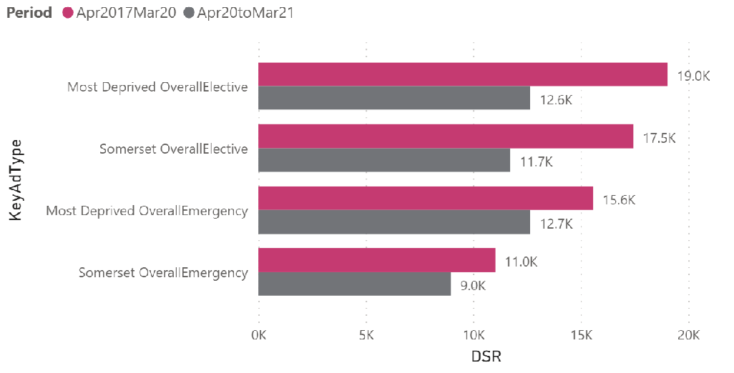
Hospital admissions
Figure 5: Change in elective and emergency admissions by deprivation - before and during pandemic (Direct Standardized Ratio)
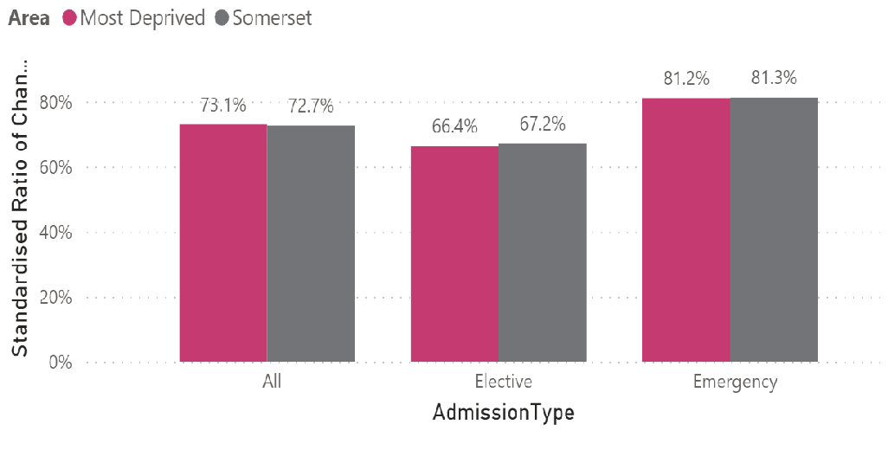
Figure 6: Standardized Ratio of Change by Admission Type and Area

Figure 7 and Figure 8 show that the proportion of emergency admissions for cancer rose in the poorer communities. This indicates that late diagnosis of cancer may be increasing there. Many health service providers report that patients are becoming more ‘complex’ – with multiple and further advanced conditions: coping with this could outlast the direct effects of COVID-19 itself.

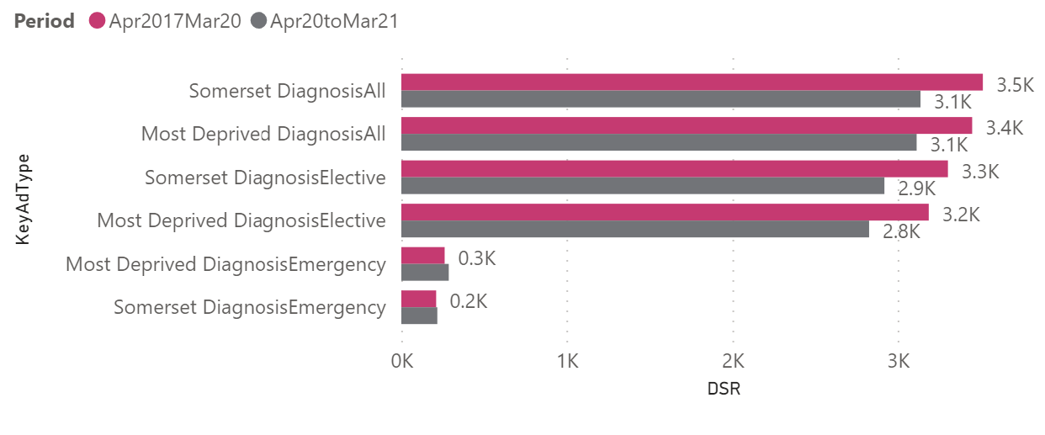
Figure 7: Direct Standardized Ratio of Cancer admissions by area

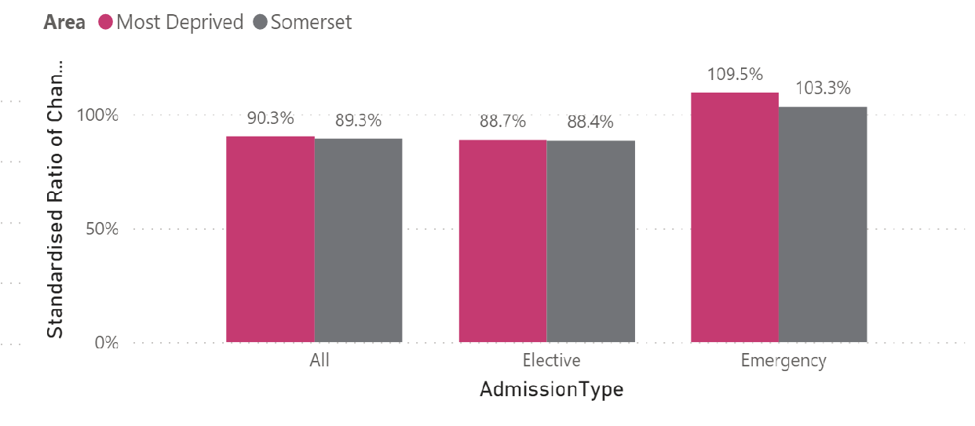
Figure 8: Change in admission patterns for cancer

Communities such as the ones being studied here, where the ‘wider determinants of health’ lead to greater health need in the population often have poorer access to health services too, exacerbating the problems in the so-called ‘inverse care law’. Fortunately, evidence suggests that this did not apply in these areas.

“I should have gone to the Beacon Centre every three months. Instead of that, it was
‘phone calls and blood tests, which was Okay.”
Bridgwater Focus Groups

Table 2 shows the Comparative Incidence Ratio and actual change in the directly standardised ratev for each measure between the three-year period before the pandemic and the 2020/21 financial year. The Comparative Incidence Ratio is the difference between the Direct Standardised Ratio in each period. A value of 100% means there has been no change, a value over 100% means that the rate has increased by that much proportionally, while a lower value indicates a similar reduction.
The most surprising outcome here is that the year of the pandemic appears to show a reduction in overall mortality for the most deprived communities but not for Somerset as a whole. Emergency admissions have similarly reduced although the reduction in the most deprived areas is identical to the overall population. Rates of elective admissions have dropped substantially - by around a third. However, the drop in the most deprived communities is similar to the rest of Somerset. So the more deprived communities do not seem to be affected more than elsewhere.
Table 2: Comparative Incidence Ratios and change in directly age-sex standardised rates per 100,000, 2017/18 to 2019/20.

Change between 2017/18-2019/20 and
2020/21
Measure | Area | Comparative  Incidence Ratio | Actual Change in DSR  per 100,000
Elective | Most Deprived Decile | 66% | -6,381
 | Somerset | 67% | -5,820
Emergency | Most Deprived Decile | 81% | -2,902
 | Somerset | 81% | -2,129
Mortality | Most Deprived Decile | 94% | -94
 | Somerset | 101% | 10
Source: NHS Digital Civil Registrations Data, NHS Digital Hospital Episode Statistics, ONS mid-year population estimates.
The impact of the pandemic on different conditions is shown in Figure 9 following. The Comparative Incidence Ratio which shows what the proportion change was between the DSR for 2017/18-2019/20 and the DSR for 2020/21. The first thing that stands out is that emergency admission and mortality for cancer has increased and disproportionally so in the more deprived communities. There has also been a small increase in emergency admissions for Dementia and Alzheimer’s despite a reduction in mortality rates. Respiratory disease has seen a considerable drop in all admissions and mortality. Mortality for circulatory and all “other” conditions has reduced more amongst more deprived areas than for Somerset overall.

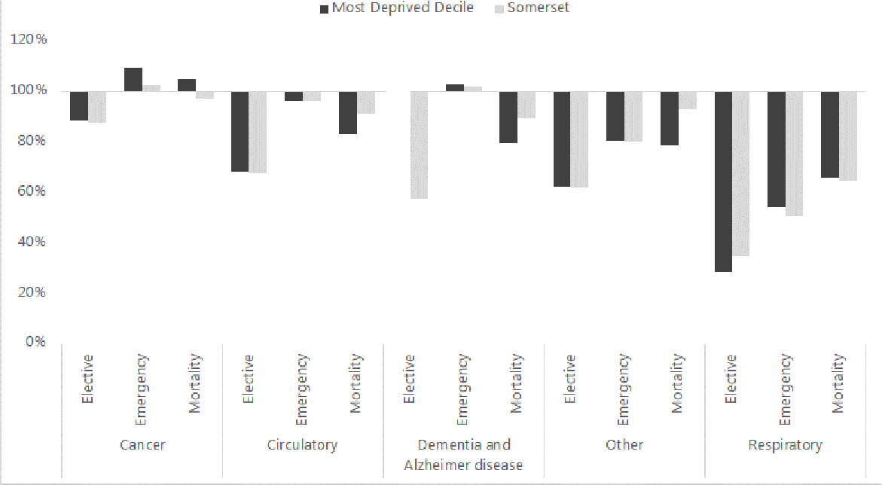
Figure 9: Comparative Incidence Ratios 2017/18 - 2019/20 by major causes Dementia and Alzheimer’s Elective
admissions not shown due to small numbers in the 2020/21 financial year.
Source: NHS Digital Civil Registrations Data, NHS Digital Hospital Episode Statistics, Office for National Statistics (ONS) mid-year population estimates.

The chart below shows how the drop in emergency admissions for respiratory conditions has been the greatest difference in actual rate with the 2020/21 rate being almost 1,000 per 100,000 lower than for the previous three-year period.
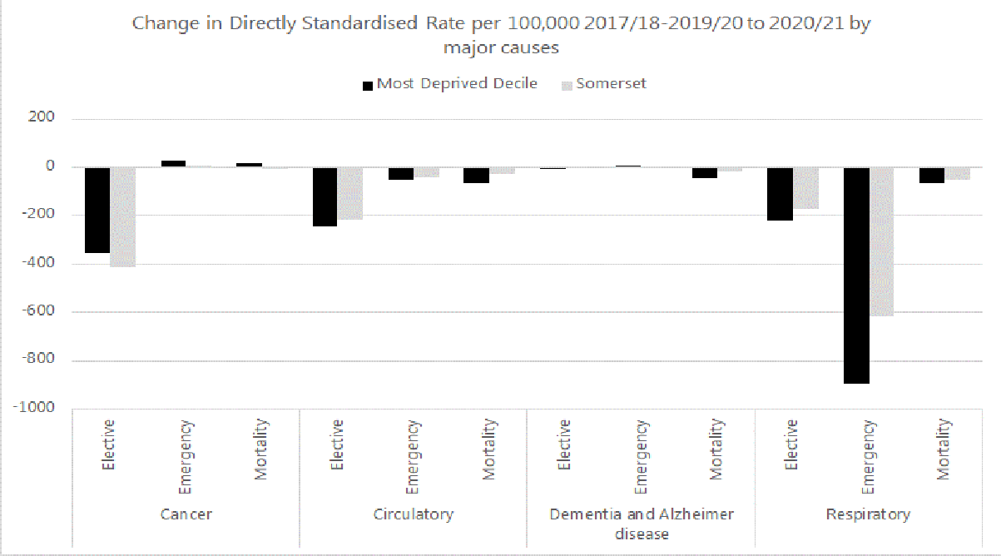
Figure 10: Change in Directly Standardized Rate/100,000 2017/18 - 2019/20 to 2020/2021 by major causes Note the “Other” category is hidden from this chart as it is much larger than any of the main categories listed. Source: NHS Digital Civil Registrations Data, NHS Digital Hospital Episode Statistics, ONS mid-year population estimates.

The number of deaths and emergency admissions linked to COVID-19 are shown in the table below.
Table 3: COVID Hospital Admissions and Mortality, 2020/21

Measure | Area | Number | DSR per 100,000
Emergency | Most Deprived Decile | 181 | 349
 | Somerset | 1,421 | 224
Mortality | Most Deprived Decile | 58 | 148
 | Somerset | 686 | 134
Source: NHS Digital Civil Registrations Data, NHS Digital Hospital Episode Statistics, ONS mid-year population estimates.
Figure 11 shows how the “new” COVID-19 emergency admissions and mortality directly standardised rates compare with the overall decline seen in both measures.
It shows that while there have been considerable numbers of emergency admissions linked to COVID-19, the overall drop for Somerset and the most deprived areas is considerably larger.
The picture for deaths is more complicated where it does appear that COVID-19 is linked with a slight increase mortality rates across Somerset; this is not the case in the most deprived areas.
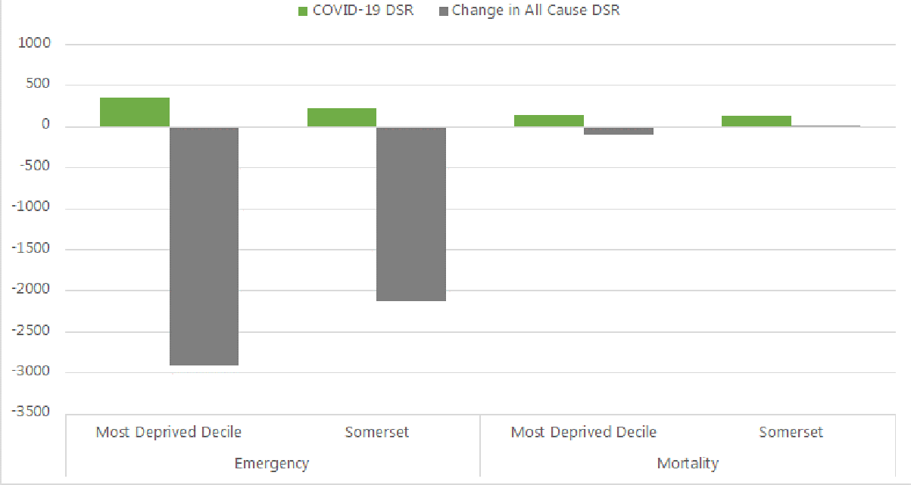
Figure 11: COVID-19 Directly Standardized Rate of Emergency Admissions and Mortality compared with the change in DSR per 100,000 2017-8/2019/20 to 2020/21
Source: NHS Digital Civil Registrations Data, NHS Digital Hospital Episode Statistics, ONS mid-year population estimates.

Mental health

Depression and anxiety
The stress of lockdown can affect anyone, but research by Public Health England suggests that the more serious impacts are amongst those:
  - at higher risk from COVID-19 (BAME, older people and with pre-existing health conditions)
  - whose work environment has higher risk of COVID-19 (e.g. health and care staff, retail, manufacturing, teachers)
  - with direct experience of COVID (bereaved; recovering from severe illness etc).
  - who experience COVID-19 as a threat to income, security and family
  - challenged by socio-economic circumstances
  - with underlying mental health conditions – adults & children

“Due to anxiety, I found it hard to access work because I wasn’t coping in my own language or in English, my partner spoke for me and did everything.”
“I think this ...accelerated any mental issues that you have and for me, mental health
issues I didn't know I had……”
“ my husband now is still very wary about going out, because we’ve been away on
things but he’s very wary. He sees a big crowd and that’s it, I mean mentally, still. I also
got very anxious afterwards [having COVID-19].”
“Shared parenting for separated parents was allowed but didn’t really work for me. Their Dad lives with a person who is vulnerable, so they have only seen him seven times since March 2020, whereas it was every week (before COVID).”
Bridgwater Focus Groups

Clearly, the evidence so far suggests that there will be a larger proportion of such people in the communities in question, and whilst not comparative, it is backed up by the qualitative findings. Further evidence of a need for support with mental health is provided by the number of calls to Mindline (for the county as a whole), which rose to a peak of 500-700 per week at the height of the lockdown.

Welfare and Wellbeing
The Citizens’ Advice Bureaux (CAB) provide support to people in need of help. The figures below show the main concerns expressed by people in Somerset during the pandemic.
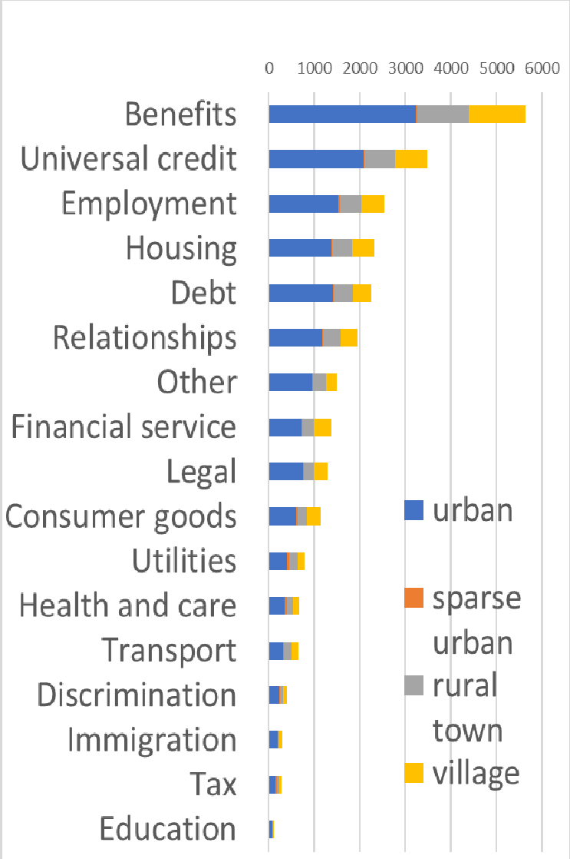
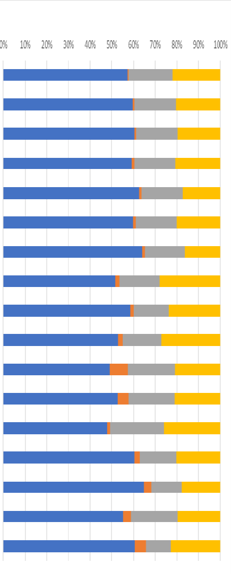
Figure 12: Citizens' Advice Bureau queries (proportion, left and numbers right)

As already mentioned, access to benefits is by far the largest category, with Universal Credit alone being in second place in the list. These were, of course, significant before the pandemic too, but since its onset the number of benefit recipients has risen considerably.
Concerns between urban and rural were remarkably similar according to CAB figures. This is not exactly comparing deprived urban with county average, but as close as we have to that. This implies that the nature of people’s needs varies little, even if the numbers in need do.
Interestingly, CABs reported that the shift from face-to-face to telephone advice had evened out some issues of poor rural access.

Economic Impact on health and wellbeing

Unemployment and Benefit claimants
Unemployment is generally higher in such deprived communities than elsewhere (by definition, indeed), and the working hypothesis that these have been hit harder by the pandemic would suggest that the rises in unemployment would be greatest here.
2.50
2.00
1.50
IMD 10%
1.00

Figure 13: Unemployment-related benefit claims (all ages, indexed to January 2020 = 1.
January…
April 2019
July 2019 October… January…
April 2020
July 2020 October… January…
April 2021
July 2021
October…

Most striking in the figure is that the onset of the pandemic led to a rapid and significant increase in unemployment in all parts of the county (and across much of the world).
Counterintuitively, the index of unemployment, as measured by benefit claimants, rose less steeply in the communities being examined. The most plausible explanation is the use of furlough, with probably some effect of a high proportion of ‘key workers’ who continued in employment.
“Little impact for me, worked all the way through as I was deemed an essential worker. ”
“Fortunately for me, I continued to be paid, but my partner was furloughed. So, he was furloughed as early as May because his company was starting to suffer. He works for the airline industry. And so we did go for a period of time when we didn't know what was going to happen with his job…..” Bridgwater Focus Groups
There has been a £20 ‘uplift’ to Universal Credit payments during the pandemic, which was widely suggested to have been significant in addressing poverty. We have heard reports that for many households this has become a ‘new normal’, and the return to pre-pandemic levels of payment in October 2021 has been suggested as a point of considerable concern, particularly with furlough ending at the same time. Thankfully, the business survey (spring

of 2021) suggests that the threat of redundancy has been much reduced since the height of the first lockdown. We have not heard reports of a significant rise in need in the immediate aftermath of these schemes ending. Lack of money was not raised in qualitative work, which may reflect reluctance to talk about it, but also hints at the effectiveness of the schemes.

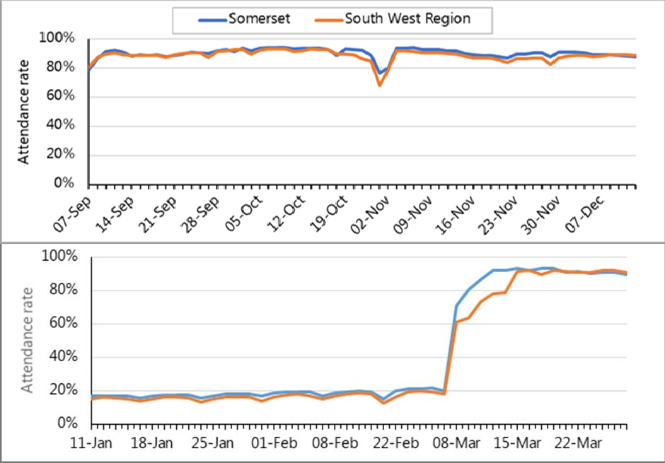
Education

.
Figure 14: Schools attendance in autumn term (above) and spring term (below, 2020-21. DfE daily data collection

During the first lockdown (March 2020) schools were only open to vulnerable children and children of critical workers, with initially around 1,500 pupils attending school daily, rising to around 2,500 by May (out of a total Somerset cohort of about 70,000 pupils). In June 2020 schools became open to certain year groups (initially Reception, Year 1, Year 6, and then latterly Years 10 and 12 on a rota basis). Daily numbers of pupils increased from around 6,000 per day at the beginning of June to 12,000 per day by the end of the school year.
From September 2020, with schools reopening to all pupils, attendance rates were around
‘normal’ (90%+). Typically about 5% were unable to attend for COVID-related reasons.

“I felt anxious, scared, kids home from school [ ] The kids (at the start) were three, seven and nine and no garden. At first the playschool was shut down completely and then we got 15 hours a week. Struggled with home schooling.”
“Obviously I was scared for the kids (four of school age at two different primaries).
Suddenly had to stay home. School support good, infants’ school was fantastic.”
Bridgwater Focus Groups

Schools were not required to complete an attendance register so Figure 14 above shows only county level figures based on Department for Education data collection. It can, though, be inferred that there was greater loss of education in the communities in question, as schools with high levels of disadvantage – based on free-school meal eligibility - have experienced on average 2.2 missed months compared to 1.5 months in those with low rates of free school meal eligibility)vi.
Following the January 2021 lockdown, overall attendance rates dropped to around 20% (when schools were again only open to vulnerable children and children of critical workers) and at which time schools will have been offering remote learning to those not ‘on site’.
Daily attendance rates returned to 90%+ in March 2021 following the reopening of schools to all pupils (although there was a phased return for most secondary pupils).
“The older kids just got on with it. I did the best I could with schooling for the younger ones. Older kids (both boys) okay, girls more emotional. Struggle with return to school for youngest in September 2020.”
Bridgwater Focus Groups

Digital access
Lockdown and social distancing have accelerated the ‘move on-line’ of services. It also had a impact on households expected to be able to home-school their children. Being able to take advantage of the opportunities requires effective internet connectivity, which is well-known as an issue in rural areas. However, easy access also needs the money to pay for equipment and line rental, and the skills and confidence to make use of it. Urban communities are usually well-provided with the former, but many people there are lacking the latter. Lack of confident access makes shopping around and accessing information harder and may mean poorer people having to pay more for services than the wealthy.
The emerging ‘internet of things’ offers opportunities for vulnerable people to be far more capable and empowered, or, if not actively managed, it could further exacerbate digital inequality.

SPARK SOMERSET case study
This lady, aged 93, lives alone with low level support. She has a weekly carer to help shopping as her mobility is restricted and she suffers from macular. She has an intense desire to learn. She had used a computer with a keyboard in the past, but effectively had to start from scratch with a tablet. A touch screen responds in 0.7 seconds to one touch but when your reactions are much slower this can mean that the touch screen gets confused.
After numerous attempts we weren’t really getting anywhere, and I could see her frustration. So, after a couple more goes, I decided we would try a stylus. Straight away her dexterity improved. We found that switching to an iPad with a better screen made a huge difference as she began to explore the World Wide Web. We found pictures of where she used to live in the 1960’s, but as her confidence grew the focus became online grocery shopping. Very quickly she was able to shop online with help, and after six months she could manage alone. The Web is now second nature to her. An inspirational lady.

Voluntary sector and social support
The pandemic saw a significant upsurge in voluntary activity, ranging from simply neighbourliness, to nationally co-ordinated NHS volunteers. The paragraph and quotations below, provided by Spark Somerset, gives a flavour.

‘Over 1200 volunteers joined the Somerset Vaccination Programme as volunteer marshalls. The first recruitment phase was during the 3rd national lockdown (December 20 – Feb 21) when hundreds of applicants came forward. Many volunteers were of working age partly due to furlough and being home-based. As the older cohorts of residents received their vaccinations, and felt safer to volunteer then the age profile has increased. More recently a number of students have joined the programme.’
A student, living in Westonzoyland, volunteered in Bridgwater by joining the marshall team at Cranleigh Gardens Pharmacy.

I am at Plymouth university studying criminal psychology, but there are no summer jobs so thought I would get some work experience and keep active which is good for my CV. It’s really Interesting to get out and speak to people after so much time being isolated: volunteering is a great way to do this.

Registered volunteers are mapped in Figure 15. It is notable that rates are lowest in the poorer communities being studied here. It cannot be taken as a measure of altruism or community service at a local levelvii, as our qualitative sources revealed high levels of family and neighbourly support.
“I had good support from my friends and from social media, but I wouldn’t know where to
get other support from."
Support from neighbours meant “our community was self-reliant – including two retired
nurses”.
Bridgwater Focus Groups

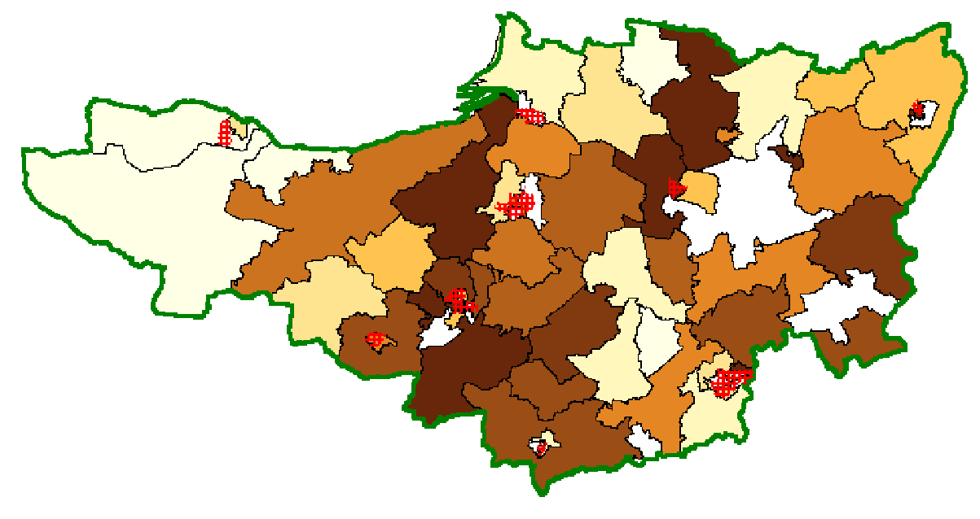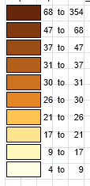
Figure 15: Estimated rate of volunteering during COVID

In response to the pandemic, over 100 community groups were created locally by residents coming together to offer mutual aid to neighbours – primarily to those advised to shield. In general, simple tasks undertaken by volunteers – friendly phone calls for example - helped to form bonds within communities and strengthened resilience. Other more practical tasks are a type of emergency response – e.g. collecting food and prescriptions.
“I have been a drug smuggler (collecting people’s prescriptions in lockdown) and people trafficker (taking people who needed lifts to get their vaccinations)!”
Bridgwater Focus Groups
Some groups established central phonelines and email addresses, or created a hub in a local shop or community premises. Groups were highly networked rather than having a formal structure. Some that emerged ‘spontaneously’ during the pandemic – starting very quickly as local Facebook groups, and using WhatsApp for operations – became formalised over time.

As an example, in Priorswood, Taunton, one such group came under the wing of the community centre. Elsewhere, churches were prominent, with the Gateway Church in Yeovil, and the Athelney Benefice in Bridgwater playing a leading role. A number have formed a ‘Good Neighbour’ scheme led by volunteers, with support from the Community Council for Somerset. Services are varied and include befriending, transport and dog-walking.
COVID volunteering was different from earlier events, such as the 2013 floods. In that case (and seen elsewhere, such as Grenfell) some charities came from outside, and notwithstanding their goodwill, did not fully understand the local context and made numerous ‘faux pas’. In the pandemic, travel was restricted and need was everywhere.
Voluntary groups, who often have to compete for limited funds, worked together cooperatively and effectively during the pandemic. The speed and informality of these groups meant that considerations such as legislation around data sharing were subservient to the business of providing support. Those that have continued, have started to give (proportionate) attention to these matters, and this sort of support (as from Spark Somerset) has been important in enabling them to do so. It is worth noting that we are unaware of any complaints about inappropriate information disclosure, given the balance of risks (see JSNA 2018).
Whilst there are overwhelmingly positive lessons to be learnt about the voluntary sector, there are unresolved questions. ‘Turf wars’ still exist, such as over the competing forms of accessibility to medicine from Internet providers (where some volunteers helped individuals receive prescriptions this way) and community pharmacies, who could deliver themselves.
Many ‘emergency’ voluntary activities have merged into a form of social prescribing, which is not necessarily integrated into the wider service. There is also a question of how far community groups should change to ‘fit’ the reporting models of their funders, and how much funders should change their operations to meet the needs of Voluntary and Community Sector (VCS) providers.

Crime and anti-social behaviour
Many of the communities in question suffered from ‘county lines’ before the pandemic. These are urban-based gangs who recruit young people in vulnerable families to sell drugs in rural areas. The police have confirmed that the pandemic does not seem to have exacerbated these problems despite the concerns we heard from those working in the areas in question. We have heard anecdotally how the harmful impact of the pandemic on parents’ mental health made children more vulnerable. This has been manifested in an increase in knife crime in Yeovil and Bridgwater.
In Figure 16 crime affecting families shows a decline initially, then a rise in the summer of 2020 and a large fall thereafter. Although the communities being studied (which include town centres) make up about 10% of the population they experience about 25% of the

crimes. The patterns in the first year of the pandemic are unclear, but the proportionate rise in the poorer communities was less than the county average.
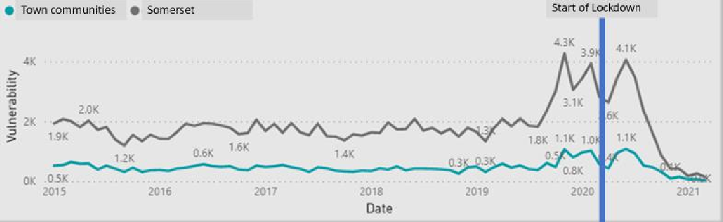
Figure 16: Recorded Crime (Transform database)

Observation (Sedgemoor Conversation)

Youth Unlimited representative

Coming out of lockdown, we have observed stress, anxiety and concerns about future aspirations from missing education etc. Young people had no experience to compare this with. The organisation had kept in contact with social media and youth workers had been doing doorstep visits. There had been an increase in assaults and bullying amongst young people, fighting amongst each other, with no or little professional services or engagement to help them. This sort of behaviour could be attention-seeking because there had been so little engagement. One to one, the young people engaged well – but now some were assaulting girls and posting it on social media – which upset their peer group but at the same time, got them attention with the ‘shock’ factor. There was an increase in risky behaviour in young people - all this negative behaviour could be a cry for help.
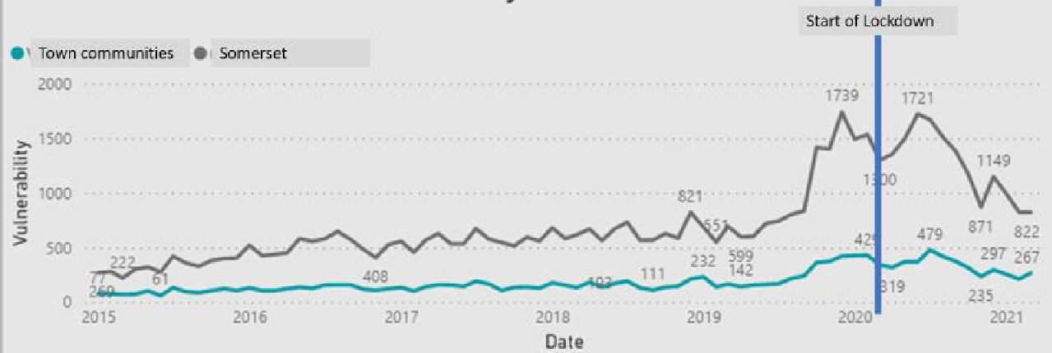
Figure 17: Domestic Abuse incidents (Transform Database)

Figure 17 above - families subject to domestic abuse - shows a rise for the communities in question after March 2021, although, as with crime as a whole, this is less marked than for the county as a whole, and considerably less than the previous September (for reasons that are not entirely clear). There were increased calls to national Domestic Abuse helplines from

the onset of the pandemic, although we could not identify such patterns in Somerset. This is perhaps best taken as an indication of the difficulties in obtaining definitive information about such a sensitive subject.
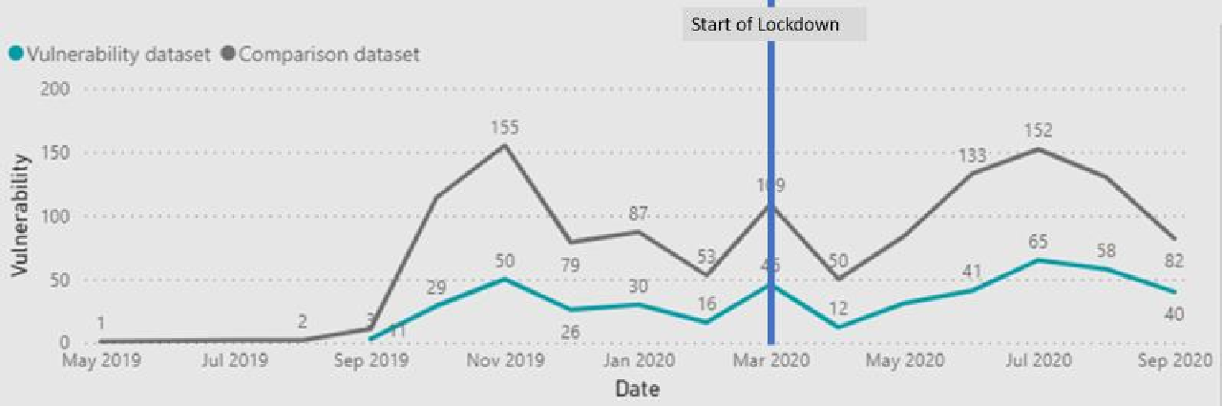
Figure 18: Anti-scocial behaviour (Transform Database)

Anti-social behaviour affecting families - ASB (Figure 18 above) - shows a decline at the start of lockdown in both the urban communities and the county as a whole. It may reflect the amount of ASB going on, or the effectiveness of recording it.
As we identified in an earlier annual JSNA, areas of concern or ‘vulnerabilities’ tend to be concentrated in a relatively small number of families, and these tend to be concentrated in the poorer urban housing estates that are a focus of this report. There has been a spike in vulnerabilities on coming out of lockdown, with the biggest rise being for children aged 10- 19, and to a lesser extent for those under 10. This has particularly involved families moving from the ‘lower’ to ‘medium’ vulnerability categories. The largest category of increase has been in that of ‘family needing support’, reinforcing the message that these concerns need to be seen at the level of the household – or more meaningfully, the family.
However, any data on children’s social need have to be treated with great caution, as changes may reflect the ability for these vulnerabilities to be identified rather than their underlying severity or prevalence. In particular, the absence of a majority of children from school has removed opportunities for teachers and other school staff to notice changes in children’s behaviour.

Drugs and Alcohol
Over the period of the pandemic, there has been evidence of an overall increase in deaths related to drugs and alcohol. Problematic substance use tends to develop slowly before someone seeks treatment, so changes as a result of the pandemic will not yet have manifested themselves.
Before the pandemic, about 25% of Somerset Drug and Alcohol Service (SDAS) clients were from the communities being studied (30% for opiates). For the 2020/21 financial year there does not appear to be any notable deviation from the existing trends. Total numbers of clients in contact with the service - and the proportion of those who are from the most

deprived LSOAs - do not show any obvious impact of the pandemic. For all areas, there was an immediate fall when lockdown was imposed, followed by a return to previous
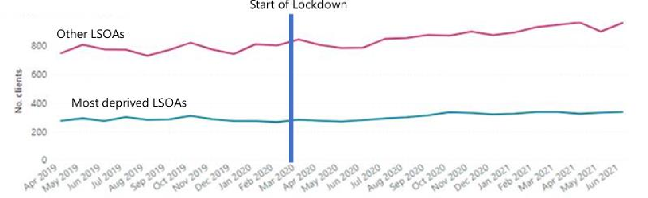
levels.
Figure 19: Clients in contact with Somerset Drug and Alcohol Services

When the pandemic and lockdown first impacted, the numbers of clients being referred for treatment (Figure 20) decreased abruptly, before gradually increasing to a more 'normal' figure over the next few months - this was seen both for clients from the most deprived areas, and those from less deprived areas.
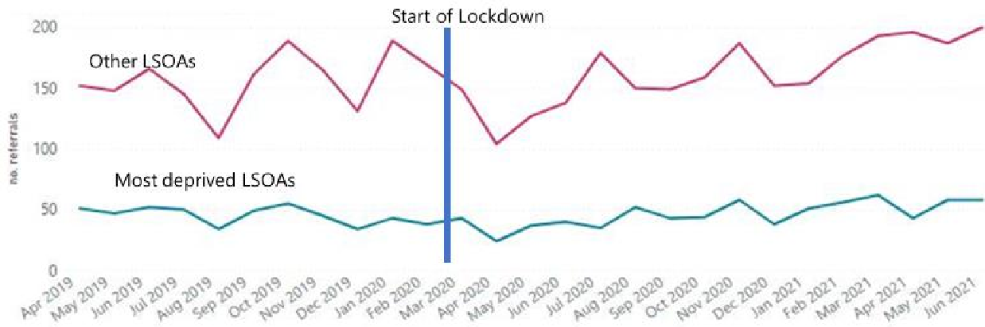
Figure 20: Clients being referred for Drug and Alcohol treatment

Interestingly, for the eight months from April to December 2020, the rate of clients from the most deprived LSOAs who dropped out within 12 weeks of starting structured treatment was lower than normal, which may reflect efforts made to keep in touch with opiate clients in particular. Anecdotally, new digital ways of operating which emerged during the pandemic, generally proved positive for service users and beneficial for levels of engagement. There was some concern around those who were digitally excluded and the impact on their ability to access support, but the provider was able to use their budget which would otherwise have been spent on travel, to support clients to access services digitally.

Although the pandemic has had an impact on alcohol-related harm, there is no data to suggest that this has been disproportionately experienced in areas of high deprivation. Nationally, hospital admissions for alcohol-specific conditions decreased around the start of the pandemic across all deprivation deciles, the rate of admissions increasing to a peak in July 2020 at the end of the first national lockdownviii.

Food and hunger
The presence of hunger in young people was a prominent aspect of the voluntary sector experience in the poorer communities of Sedgemoor, and it is highly likely that this is typical of such communities elsewhere. It was also an important focus of the response, with the Community Council for Somerset providing the equivalent of the entire food needs of 400 people, many of them shielding. The available data do not paint a definitive pattern of food need during the pandemic. The COVID vulnerability index produced by the Red Cross (see Figure 21), which includes a large element of access to food, emphasises rural communities where distance is a factor. It is also unclear the extent to which the hunger revealed in qualitative work existed before the pandemic or was caused by it, or whether it is transitory and occasional for some families or a more long-term need. Whichever it is, this is probably the most significant immediate need described here.
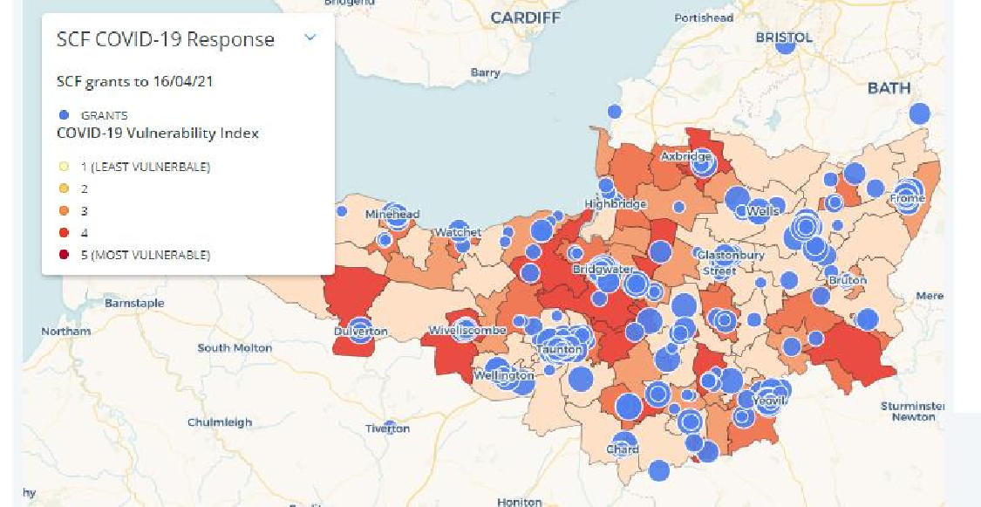
Figure 21: Somerset Community Fund grants, showing Red Cross COVID Vulnerability Index

Observations (Sedgemoor Conversation) Youth Unlimited

There was also the importance of engagement around food and the shame around not having food. A COVID friendly café project has been set up for young people – this has exposed food poverty amongst this group and the households they live in. Food has always been a brilliant way to engage with young people, and there are so many things to be learned from it but at the moment the young people they’re seeing are hungry. Food has become something that’s being provided regularly now and future funding needs to reflect the need for a proportion of that to provide food to the group. The other benefits will still be there around social education and it removes the shame of having to ask for food when they attend.

Somerset Sports and Activity Partnership (SASP)
SASP delivered the Marcus Rashford Holiday Activity and Food scheme in summer 2021 (focusing on children on Free School Meals) and saw increased need. Around 45,000 places were provided - 83% booked and 68% attended. SASP gave extra funds to providers so that children could cook food during their activities, to take home to their families. Food security is a serious issue, with some children going to school with nothing to eat.

Vaccination
Nationally, the vaccine programme has largely prioritized older people, and so it should be no surprise that the take up has been lower in the communities being studied. Furthermore, there has been an identified national association between high scores on the IMD and low vaccination ratesix. Unsurprisingly, then (at the time of writing, October 2021) the lowest rates in Somerset have been in these areas. For example, while Sedgemoor district as a whole has a rate of 72.3% first vaccination (of total population) the rate for Bridgwater Primary Care Network area is only 69.8%, with the lowest rates being in the poorer communities. The town centre of Yeovil has a rate of only 58%. The estimated level required for ‘herd immunity’ for the delta variant is 85%, so whilst no areas yet reach that threshold, it is clear that outbreaks will more easily establish themselves in the poorer communities of Somerset.

There was near universal praise for the vaccine roll out and the sense of safety/recovery
that it engendered. “I got priority because I am a carer for my mum”.
Bridgwater Focus Groups

Conclusions

Whilst COVID-19 has caused illness and death directly, and the consequence of measures that have had to be taken in response have had their own harmful side-effects, it has not been a simple worsening of existing inequality. Focusing on where need was greatest before the pandemic in Somerset has shown that the impacts have been far from simple – indeed, given that it has been the most severe pandemic for at least a century, and the sharpest economic downturn since the Great Frost of 1709, it should be no surprise that the effects are similarly unprecedented.
Some of the explanation is that, for all the importance of local inequality, Somerset does not show the harsh contrasts between rich and poor, stable health and ill, that are seen in major cities, notably London. The absence of a university may have helped Somerset avoid population-mixing and transmission that occurred in the larger cities. Within Somerset, COVID-19's direct impact has been greater in poorer communities, but not dramatically so.
Economic, social and welfare effects have been significant, but perhps more subdued than expected in these communities. The unprecedented responses of furlough and the £20 universal credit have undoubtedly reduced the impact in these areas where accommodation and retail jobs dominate, and which had the highest level of benefit claimants before COVID- 19.
We also heard about the strength of family and neighbourly support: this is ‘community resilience’ in action. For some people, worklessness and ill-health was the norm before COVID-19, and when the pandemic arrived, their existing coping mechanisms helped them through, especially at the start.
The information available to understand patterns of need has largely depended on using support provided to address that need. That is often the case, but in a fluid and unprecedented health, economic and social event, the limitations of data have been very apparent.
As the pandemic has progressed, so the pressure and anxieties it has caused have increased steadily, and need has risen. These communities remain, on most measures of health and wellbeing, the most needy in the county, and mental health concerns – in particular anxiety – show every sign of increasing steadily, even if vaccination has lessened the direct impacts.

Implications for commissioning

These communities continue to show concentration of need after the start of the pandemic, and improving the overall health of the population by addressing the needs of the most needy first and fastest, will continue to require a focus on them.
The apparent effectiveness of innovative responses such as furlough should encourage further innovation in addressing community needs.
The informality of community support in these communities is vital, but may be less ‘visible’
to official services, and require more effort to join-up with.

The importance of digital access has been highlighted. Improving accessibility is about skills and confidence as much as equipment and infrastructure, and done well, it can bring benefits to service users and service providers alike.
These communities were the most vulnerable in Somerset before the pandemic, and their position has weakened further as a result. However, given the complexity of impacts, there is a risk that other communities or population cohorts elsewhere (such as those who were ‘just about managing’) have been hit even harder, and may lack the experience and coping mechanisms evidenced in the poorer urban centres. There may, for instance, be overlooked issues of physical or digital access in rural areas exposed, unexpectedly, by this study of urban areas.

References

i This is based on statistical geographies and the boundaries do not necessarily have much meaning ‘on the ground’, and indeed some statistics are reported on a different basis, so they are only indicative is some cases. It is also important to note that as a local study this is 10% of Somerset LSOAs. As Somerset has relatively low levels of deprivation, the areas defined have nearly the same result
ii The figures for school age education (KS2, KS4 and school attendance) are from 2016, and updated with each edition of the IMD. Adult skills are based on the 2011 census, and so not suitable fro monitoring between census points.
iii Prevalence of ongoing symptoms following coronavirus (COVID-19) infection in the UK - Office for National Statistics (ons.gov.uk)
iv The data in this section shows the rates of mortality and of both emergency and elective hospital admissions. The rates are standardised for age and sex meaning that they take account of any differences in the age and sex distribution of different populations. In this case the differences between Somerset’s population in the three-year period between April 2017 and March 2020 (2017/18-2019/20) and the latest financial year between April 2020 and March 2021.
Mortality means the number and rates of people dying, emergency admissions are those unplanned admissions in response to an immediate and unexpected medical need. They can be both unpleasant and costly while often being avoidable through preventative action. Potentially preventable emergency admissions | The Nuffield Trust
Elective admissions are different. The King’s Fund summarise elective care as “planned care. Most interactions with elective hospital services arise as a result of a patient being referred to outpatient services for tests and advice. After an initial appointment, the patient may be re-called for further outpatient appointments or may require admission to hospital as an inpatient for further treatment. Providing the patient does not need immediate admission, this is classed as an elective admission. This is the standard route for many common operations including cataract removal, hip and knee replacements”. How hospital activity in the NHS in England has changed over time | The King's Fund (kingsfund.org.uk)
Unlike emergency admissions and mortality elective care can therefore have a considerable impact on
improving people’s health, wellbeing and independence and is often considered a positive activity.

v Standardized for age and sex of the population
vi Pupils' progress in the 2020 to 2021 academic year: interim report - GOV.UK (www.gov.uk)
vii There are numerous sources of weakness in the data, which compare records at a post-code sector level with census-based LSOAs. The process of recording post-codes, converting data to a new geography and then estimating rates has risks at each stage. It is though, unlikely that the very broad patterns have been distorted beyond use.
viii
https://assets.publishing.service.gov.uk/government/uploads/system/uploads/attachment_data/file/10 02627/Alcohol_and_COVID_report.pdf

ix
https://www.ons.gov.uk/peoplepopulationandcommunity/healthandsocialcare/healthandwell being/bulletins/coronavirusandvaccinehesitancygreatbritain/28aprilto23may2021

